0. Introduction
This tutorial shows how to apply texture coordinates to a mesh.
Your model should be finished. All unnecessary vertexes should be merged. Every future modification of your model will destroy the texture coordinates of the affected faces!
We will use LSCM, acronym for Least Squares Conforming Map, which is one of the algorithms for unwrapping a mesh onto the 2-dimensional UV space. It is a very powerful unwrapping method because it attempts to preserve the shape of each face.

1. Mark seams (Naht/Rand)
- Go into 'Edit Mode' and activate 'Edge select mode'.
- Now you have to tell the UV unwrapper where you want to cut your mesh. Select the appropriate edges, press CTRL+e and select 'Mark Seam'.
- You can remove seams by pressing CTRL+e and select 'Clear Seam'.
- Hint: More seams reduce deformation but make the texture more difficult to paint!
- Hint: Try to make seams where the texture of the mesh has natural borders.

2. Unwrap the mesh
- To make a second 3D view port click the RMB near the border in the 3D view port and select 'Split Area'. Set its window type to 'UV/Image Editor' with the drop down box on the far left or with SHIFT + F10.

UV/Image Editor icon

- Set the window mode of the first Window to 'UV Face Select' (this mode is another mode like 'Edit Mode' or 'Object Mode', and can be set using a drop-down box at the bottom of the 3D view port).

- Select all faces (a key), and hit u and then 'unwrap' to use LSCM (Blender >= 2.42).
- Now you should see your unwrapped mesh in the 'UV/Image Editor' window.
- Hint: If you have a very complex mesh it may be better to unwrap your model in several small steps.

3. Modify UV coordinates
- This step is optional. Try to optimize the layout of your unwrapping by using the whole area and by reducing deformations.
- Hint: Make sure 'Select ' -> 'Stick Local UVs to Mesh Vertex' is on.
- Shortcuts for the 'UV/Image Editor':
grab: g
rotate: r
scale: s
pinning: p
unwrap: e
select linked ones: l
- You can "pin" (anheften) vertices with P. Make sure you put at least one pin on every island. You can remove all pins with ALT+P. LSCM works by trying to maintain the angles between each vertex. If an unwrapping should be symmetrical and it's not, try putting one pin in the middle of the outside edge of the big side and one on the small side, and unwrapping again with E. (watch uvtut.avi for a good example)

4. Export the UV-map
- Press 'UVs' -> 'Save UV face layout' in the 'UV/Image Editor' to save your UV layout to a tga file.

5. Paint the Texture
- Load your exported UV layout into your favourite painting program (e.g. The GIMP). Use it as a background image and paint your texture on new layers.
- Make your texture in a big resolution (1024x1024) and keep the dimension a power of two.
- Export your image as png or jpg.

6. Apply the Texture
- Load your texture in the 'UV/Image Editor' with 'Image' -> 'Open'.
- Back in the 3D view port, put it in Object mode and set the Draw Type to Textured. Hit TAB a couple of times to refresh your object. Now you should see your texture on the mesh in the 3D view port.
- Create a new material (normally there is already a default material assigned, so it is not necessary) press F9 and click on 'new' in the 'Links and Materials' menu tab.
- Select your mesh in the object mode.
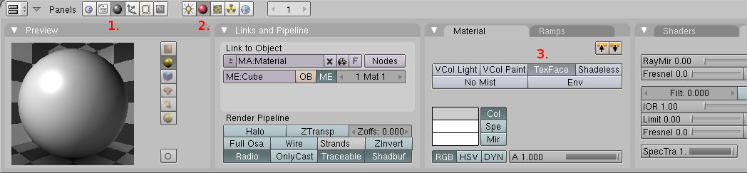
- Set 'TexFace' on your material in the material menu, so the material uses the image from the 'UV/Image Editor'. (see screen shot)

- Now you can render (F12) your mesh with your texture visible. Enjoy!

Sources:
http://en.wikibooks.org/wiki/Blender_3D:_Noob_to_Pro/UV_Map_Basics
http://www.ibiblio.org/bvidtute/mytut/uvtut.avi

